Score Loading Issue
If you get the following message when trying to view a score, you will need to upgrade your version of the Scorch player:

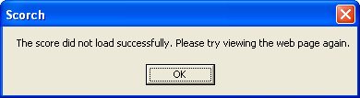

Upgrading your Scorch Player
The following procedure will work if you use Internet Explorer as your web browser. If you use Firefox, you will need to follow a slightly different procedure. Please email the website Administrator if you can’t figure it out.

- Make sure that you have closed your web browser.

- To fix this, download the latest scorch program by browsing to or clicking on: http://www.sibelius.com/download/software/win/InstallScorch.exe

- You should see the following message appear:
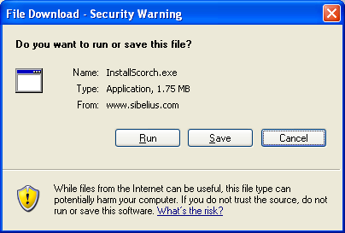

Click ‘Run’. This could take a few minutes while it downloads the new software.

- Next, you might see a message that says:
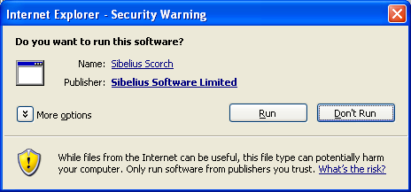

If you see that, click ‘Run’ again.
- When you see the following message, click ‘Next’:
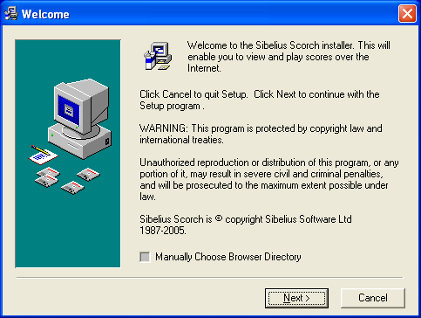

- When you see the following message, click ‘I Agree’:
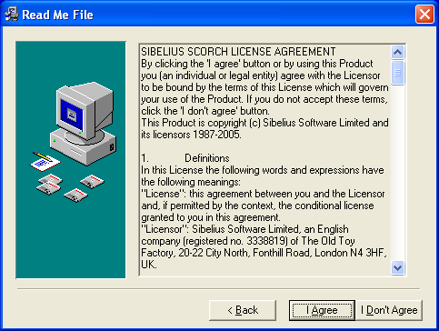

- You are done. Now try to view the score again and it should work fine.

